هذا الملف تم حَلّه من قبل الطالب: ليث عمرو.
هذه الحلول هي جهد بشري قابل للخطأ،
إن أصبت فمن الله، وإن أخطأت فمني ومن الشيطان.
هذا العمل مقدم ثوابه لروح والدي (قــــاســــم مــــفــــيــــد عــــمــــرو)
فمن وجد فيه فائدة فليدْعُ له بالرحمة والمغفرة.
Problem #1: Choose the correct answer. [7 * 1pt]
- How many bits are represented by the constant X"56" in VHDL?
  - 4 bits
  - 16 bits
  - 2 bits
  - None of the above
Sol = 8 bits
- In VHDL, how are multiple process blocks executed?
  - They run in a sequential way
  - Only one process runs at a time
  - They run one after another
  - They run concurrently

- What is the correct order of sections in a VHDL file?
  - Entity declaration, Library declaration, Architecture, Configuration
  - Architecture, Entity declaration, Library declaration, Configuration
  - Configuration, Library declaration, Architecture, Entity declaration
  - Library declaration, Entity declaration, Architecture, Configuration
- How is code executed inside a VHDL process?
  - Concurrently (parallel)
  - Sequentially (one after another)
  - Randomly
  - Only during simulation

- How is code executed outside a VHDL process?
  - Concurrently (parallel)
  - Sequentially (one after another)
  - Only at compile time
  - Never executed

- What VHDL element is used for communication between processes or entities?
  - Variable
  - Signal
  - Constant
  - Port

- Which VHDL element defines a reusable submodule for another design?
  - Entity
  - Package
  - Component
  - Function

Problem #2: The following VHDL code describes a digital circuit. Based on the code, draw the corresponding logic circuit. [10pts]
library IEEE;
use IEEE.STD_LOGIC_1164.ALL;

entity mux2to1 is
Port ( a0, a1, s : in STD_LOGIC;
y : out STD_LOGIC );
end mux2to1;

architecture Structural of mux2to1 is

component and_gate Port ( a : in STD_LOGIC; b : in STD_LOGIC; y : out STD_LOGIC );
end component;

component or_gate Port ( a : in STD_LOGIC; b : in STD_LOGIC; y : out STD_LOGIC );
end component;

component not_gate Port ( a : in STD_LOGIC; y : out STD_LOGIC );
end component;

signal sn, d0, d1 : STD_LOGIC;

begin

NOT1: not_gate port map ( a => s, y => sn );

AND1: and_gate port map ( a => sn, b => a0, y => d0 );

AND2: and_gate port map ( a => s, b => a1, y => d1 );

OR1: or_gate port map ( a => d0, b => d1, y => y );

end Structural;
Solution:
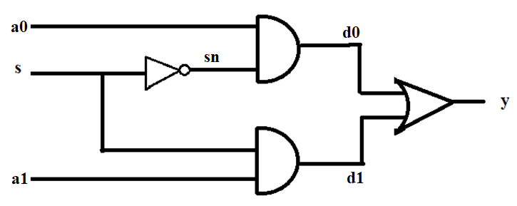

Problem #3: Design a 3-to-8 decoder in VHDL with an enable input. The decoder has INPUT has 3bits and 8 outputs (D0 to D7). [10pts]
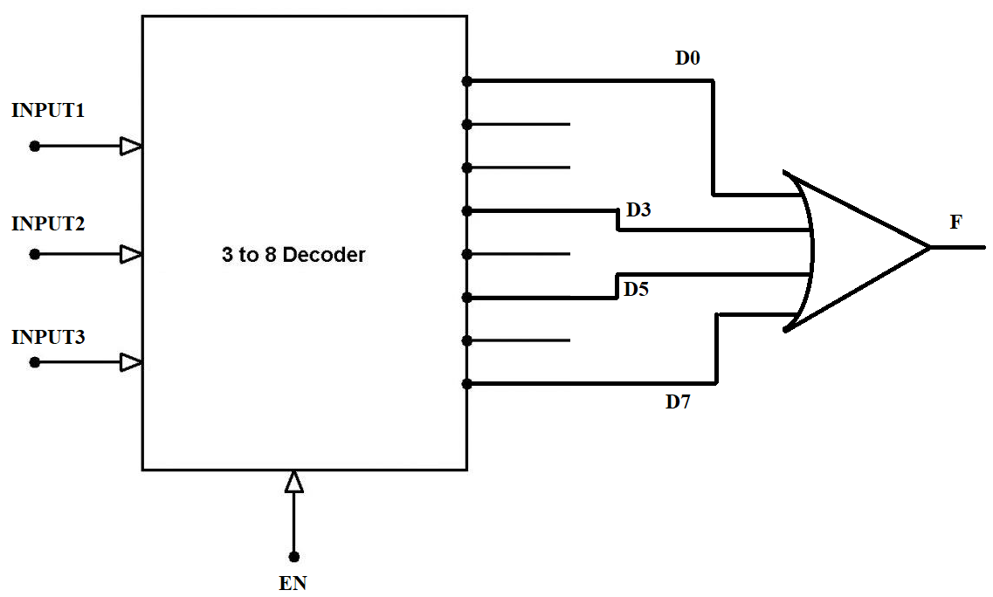

Solution (Behavioral):
library IEEE;
use IEEE.STD_LOGIC_1164.ALL;

entity decoder3x8_with_or is
Port ( INPUT : in STD_LOGIC_VECTOR(2 downto 0);
EN : in STD_LOGIC;
F : out STD_LOGIC );
end decoder3x8_with_or;

architecture Behavioral of decoder3x8_with_or is
signal D : STD_LOGIC_VECTOR(7 downto 0); -- Decoder outputs
begin

process(INPUT, EN)
begin
D <= (others => '0'); -- Default: all outputs off
if EN = '1' then
case INPUT is
when "000" => D(0) <= '1';
when "001" => D(1) <= '1';
when "010" => D(2) <= '1';
when "011" => D(3) <= '1';
when "100" => D(4) <= '1';
when "101" => D(5) <= '1';
when "110" => D(6) <= '1';
when "111" => D(7) <= '1';
when others => D <= (others => '0');
end case;
end if;
end process;

F <= D(0) or D(3) or D(5) or D(7);

end Behavioral;
Solution (Dataflow):
library IEEE;
use IEEE.STD_LOGIC_1164.ALL;

entity decoder3x8_with_or is
Port (
INPUT : in STD_LOGIC_VECTOR(2 downto 0);
EN : in STD_LOGIC;
F : out STD_LOGIC
);
end decoder3x8_with_or;

architecture Dataflow of decoder3x8_with_or is
signal D : STD_LOGIC_VECTOR(7 downto 0);
begin

D(0) <= '1' when (EN = '1' and INPUT = "000") else '0';
D(1) <= '1' when (EN = '1' and INPUT = "001") else '0';
D(2) <= '1' when (EN = '1' and INPUT = "010") else '0';
D(3) <= '1' when (EN = '1' and INPUT = "011") else '0';
D(4) <= '1' when (EN = '1' and INPUT = "100") else '0';
D(5) <= '1' when (EN = '1' and INPUT = "101") else '0';
D(6) <= '1' when (EN = '1' and INPUT = "110") else '0';
D(7) <= '1' when (EN = '1' and INPUT = "111") else '0';

F <= D(0) or D(3) or D(5) or D(7);

end Dataflow;

Problem #4: Write the VHDL code for this N-bit buffer using a generic for N with a given appendix for buffer1_bit.vhd (last page) . Then write a testbench to test the buffer. [15 pts]
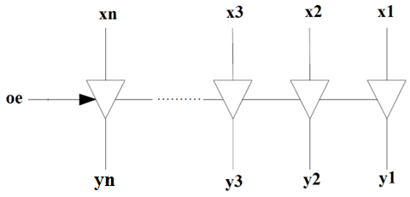
buffer_nbit.vhd
library IEEE;
use IEEE.STD_LOGIC_1164.ALL;

entity buffer_nbit is
generic ( N : integer := 8 );
port ( x : in STD_LOGIC_VECTOR(N-1 downto 0);
oe : in STD_LOGIC;
y : out STD_LOGIC_VECTOR(N-1 downto 0) );
end buffer_nbit;

architecture Structural of buffer_nbit is
component buffer_1bit port ( x : in std_logic; oe : in std_logic; y : out std_logic );
end component;
begin
gen_buffer: for i in 0 to N-1 generate
bit_buffer: buffer_1bit
port map ( x => x(i), oe => oe, y => y(i) );
end generate gen_buffer;

end Structural;
tb_buffer_nbit.vhd
library IEEE;
use IEEE.STD_LOGIC_1164.ALL;

entity tb_buffer_nbit is
end tb_buffer_nbit;

architecture Behavioral of tb_buffer_nbit is
constant N : integer := 4;
component buffer_nbit
generic ( N : integer );
port ( x : in STD_LOGIC_VECTOR(N-1 downto 0);
oe : in STD_LOGIC;
y : out STD_LOGIC_VECTOR(N-1 downto 0) );
end component;

signal x_tb : STD_LOGIC_VECTOR(N-1 downto 0);
signal oe_tb : STD_LOGIC;
signal y_tb : STD_LOGIC_VECTOR(N-1 downto 0);
begin

uut: buffer_nbit generic map (N => N) port map ( x => x_tb, oe => oe_tb, y => y_tb );

stim_proc: process
begin
x_tb <= "1010";
oe_tb <= '0';
wait for 10 ns;

-- Test case 2: Output enabled
oe_tb <= '1';
wait for 10 ns;
end process;
end Behavioral;
Problem #5: Write VHDL code to implement the following Finite State Machine (FSM) diagram, where the output y will be '1' if the value of three consequent inputs of input x is
1-2-3, which represents a password. [10 pts]
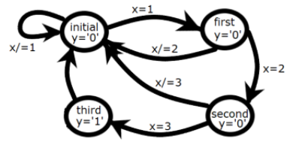
Solution (One Process)
library IEEE;
use IEEE.STD_LOGIC_1164.ALL;

entity fsm_password is
Port ( clk, rst : in STD_LOGIC;
x : in STD_LOGIC_VECTOR(1 downto 0);
y : out STD_LOGIC );
end fsm_password;

architecture Behavioral of fsm_password is
type state_type is (S0, S1, S2, S3);
signal state : state_type;
begin

process(clk, rst)
begin
if rst = '1' then
state <= S0;
elsif rising_edge(clk) then
case state is
when S0 =>
if x = "01" then -- x = 1
state <= S1;
else
state <= S0;
end if;

when S1 =>
if x = "10" then -- x = 2
state <= S2;
else
state <= S0;
end if;

when S2 =>
if x = "11" then -- x = 3
state <= S3;
else
state <= S0;
end if;

when S3 =>
state <= S0;

end case;
end if;
end process;

y <= '1' when state = S3 else '0';

end Behavioral;

Solution (Two Process)
library IEEE;
use IEEE.STD_LOGIC_1164.ALL;

entity fsm_password is
Port (
clk, rst : in STD_LOGIC;
x : in STD_LOGIC_VECTOR(1 downto 0);
y : out STD_LOGIC
);
end fsm_password;

architecture Behavioral of fsm_password is
type state_type is (S0, S1, S2, S3);
signal current_state, next_state : state_type;
begin

-- Process 1: State register (sequential)
process(clk, rst)
begin
if rst = '1' then
current_state <= S0;
elsif rising_edge(clk) then
current_state <= next_state;
end if;
end process;

-- Process 2: Next state and output logic (combinational)
process(current_state, x)
begin
-- Default assignments
next_state <= current_state;
y <= '0';

case current_state is
when S0 =>
if x = "01" then -- x = 1
next_state <= S1;
end if;

when S1 =>
if x = "10" then -- x = 2
next_state <= S2;
else
next_state <= S0; -- Reset on wrong input
end if;

when S2 =>
if x = "11" then -- x = 3
next_state <= S3;
else
next_state <= S0; -- Reset on wrong input
end if;

when S3 =>
y <= '1'; -- Output pulse
next_state <= S0; -- Auto-reset after success
end case;
end process;

end Behavioral;

Appendix: buffer_1bit.vhd
library IEEE;
use IEEE.STD_LOGIC_1164.ALL;

entity buffer_1bit is
Port (
x : in STD_LOGIC; -- Input data
oe : in STD_LOGIC; -- Output enable
y : out STD_LOGIC -- Output
);
end buffer_1bit;

architecture Behavioral of buffer_1bit is
begin
y <= x when oe = '1' else 'Z'; -- Tri-state logic
end Behavioral;

تم بفضل الله، اللهم ارحم عبدك ( قــــاســــم مــــفــــيــــد عــــمــــرو ) واجعله من ورثة جنّة النعيم.

